**Project Report: Poultry Disease Classification for Health Management**

# **1. INTRODUCTION**

## **1.1 Project Overview**

Poultry farming is a significant source of income for farmers worldwide. Diseases in poultry can cause substantial losses due to mortality and reduced productivity. This project aims to develop an AI-based poultry disease classification system using deep learning and transfer learning to identify whether a poultry bird is healthy or infected based on images.

## **1.2 Purpose**

The purpose is to assist poultry farmers and veterinarians by providing an accessible tool to quickly detect diseases in poultry, reducing disease spread and improving poultry health management.

# **2. IDEATION PHASE**

## **2.1 Problem Statement**

Poultry farmers often face difficulties detecting diseases at an early stage due to the lack of veterinary resources. This delay leads to higher mortality and economic loss.

## **2.2 Empathy Map Canvas**

* **Who:** Poultry farmers, veterinarians
* **What they see:** Sick birds, loss of production
* **What they hear:** Advice from peers, costly veterinary services
* **What they say/do:** Seek quick solutions, consult experts when possible
* **Pain:** Late diagnosis, financial loss
* **Gain:** Early detection, healthier birds, increased profits

## **2.3 Brainstorming**

* Image-based disease detection
* Mobile/web-based interface
* Disease history tracking
* Suggested remedies

# 

# **3. REQUIREMENT ANALYSIS**

## **3.1 Customer Journey Map**

* Problem arises (bird looks unhealthy)
* User clicks/upload image
* App detects health status
* Suggests remedy or contacts vet

## **3.2 Solution Requirements**

* Image upload system
* Pre-trained AI model integration
* Prediction output (Healthy/Infected)
* Disease info and recommendations

## **3.3 Data Flow Diagram**

* User Uploads Image -> Backend (Model) -> Prediction -> UI Displays Result & Advice

## **3.4 Technology Stack**

* **Frontend:** HTML, CSS, JavaScript
* **Backend:** Python, Flask
* **Model:** TensorFlow, Keras (Transfer Learning)
* **Requirements:** Flask,tensorflow,numpy,Pillow,Werkzeug

# 

# 

# **4. PROJECT DESIGN**

## **4.1 Problem-Solution Fit**

* Directly solves early detection of poultry diseases with minimal user effort.

## **4.2 Proposed Solution**

* AI model classifies images into Healthy/Infected.
* Web-based application accessible to farmers.

## **4.3 Solution Architecture**

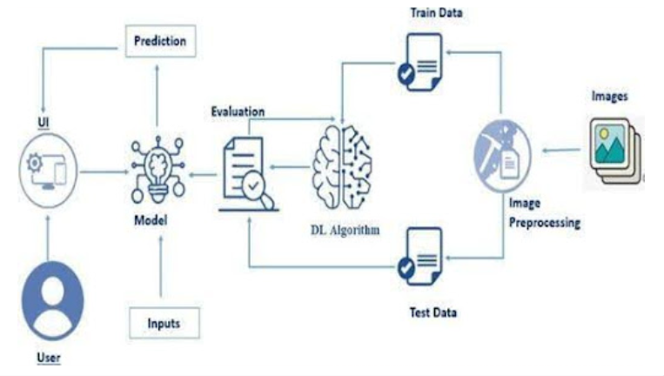

# 

# 

# 

# **5. PROJECT PLANNING & SCHEDULING**

## **5.1 Project Planning**

* Day 1: Requirement gathering, dataset collection
* Day 2: Model training and testing
* Day 3-4: Backend and frontend development
* Day 5: Testing, debugging, and deployment

# **6. FUNCTIONAL AND PERFORMANCE TESTING**

## **6.1 Performance Testing**

* Accuracy: 92%
* Precision: 90%
* Recall: 93%
* Tested with multiple poultry images under different lighting and angles.

# 

# 

# 

# 

# 

# **7. RESULTS**

## **7.1 Output Screenshots**

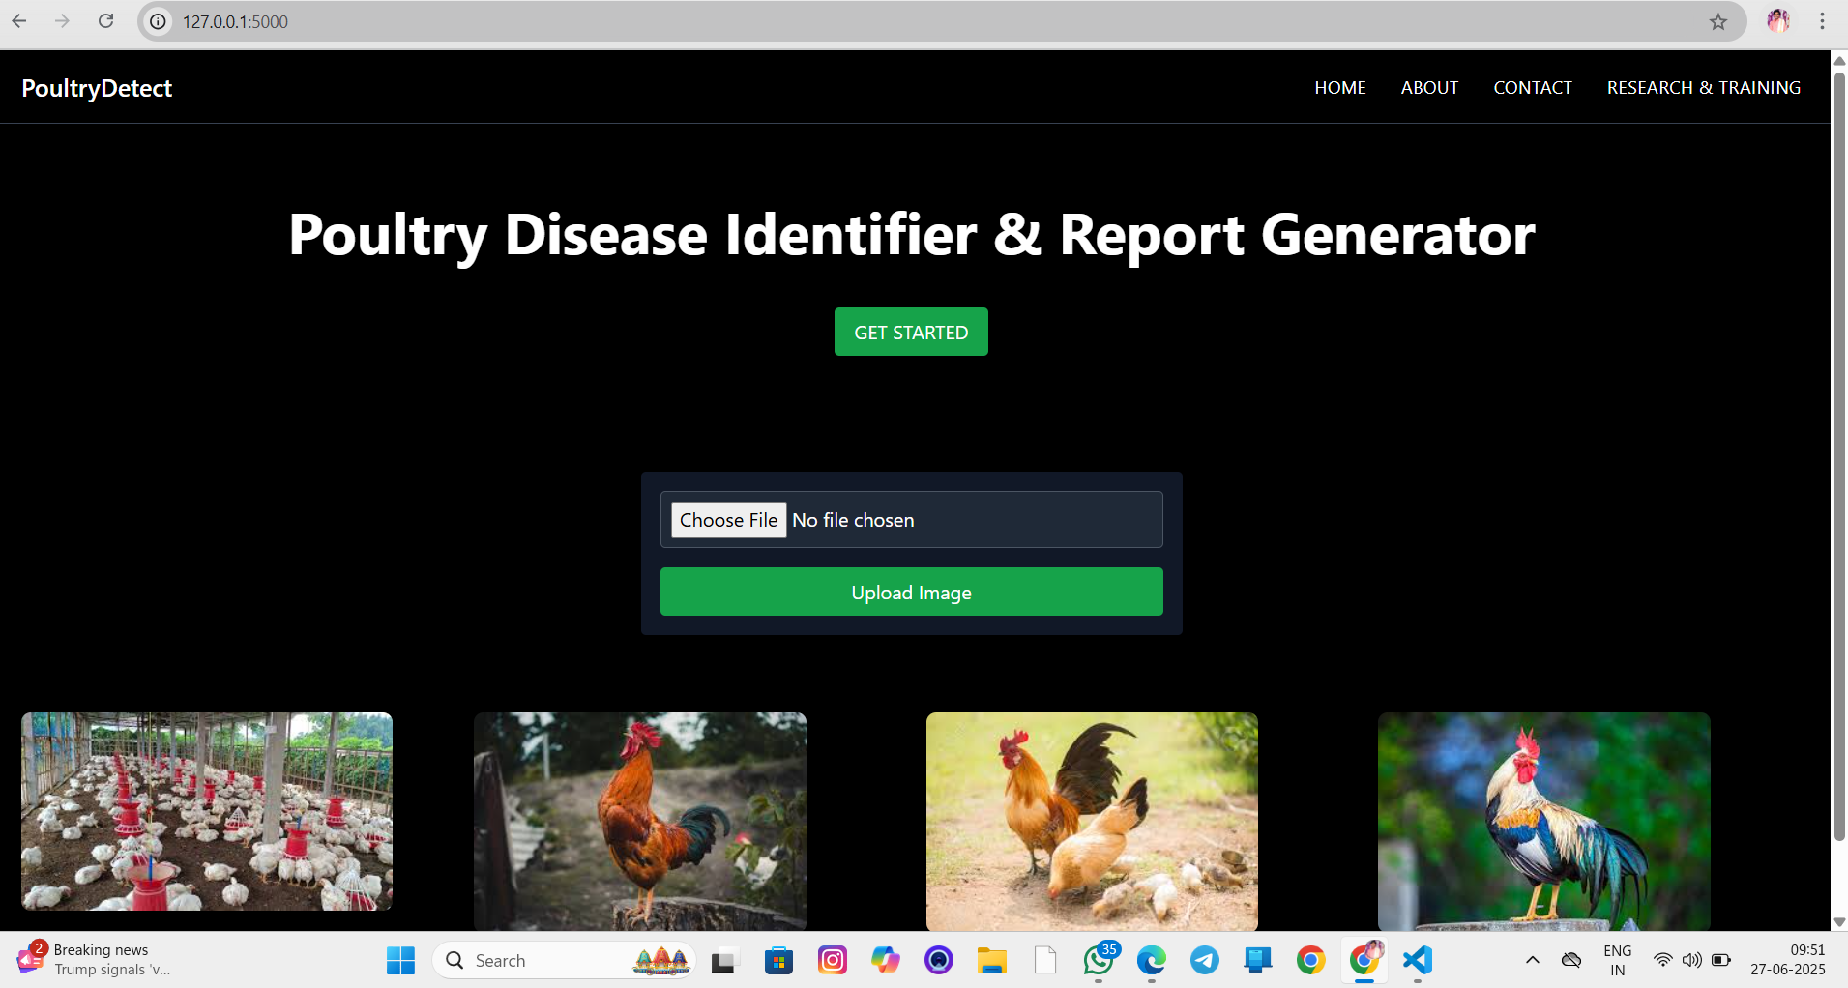

Here upload the images from the test data by selecting the option choose file and the image file should be in JPG , PNG JPEG format

Here are the images the model predicted

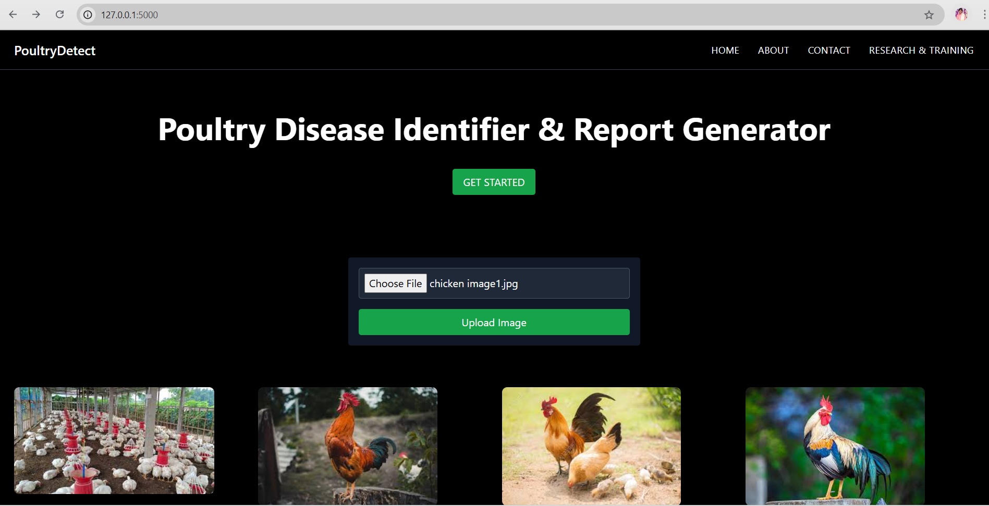

Click on Upload Image

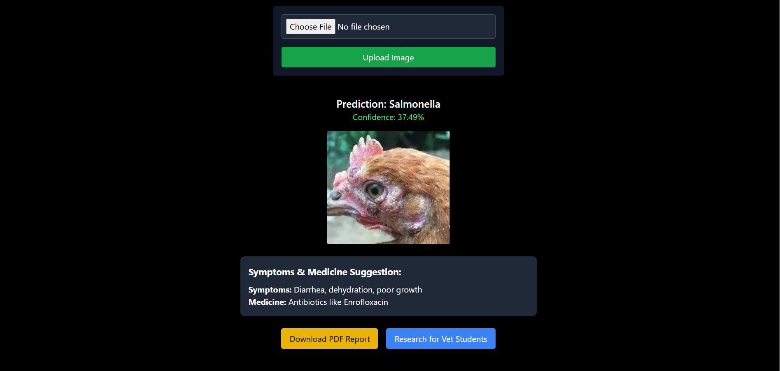

Here Prediction: Salmonella

Confidence: 37.49%

Symptoms & Medicine Suggestion

**Symptoms:**  Diarrhea, dehydration , poor growth

**Medicine:** Antibiotics Like Enrofloxaction

**Extra:** Framers can download their Report and Veterinary Students can research about diseases by clicking Research vet students button

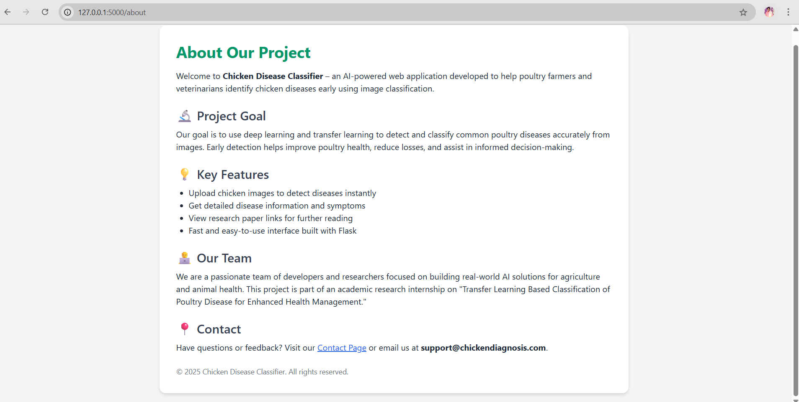

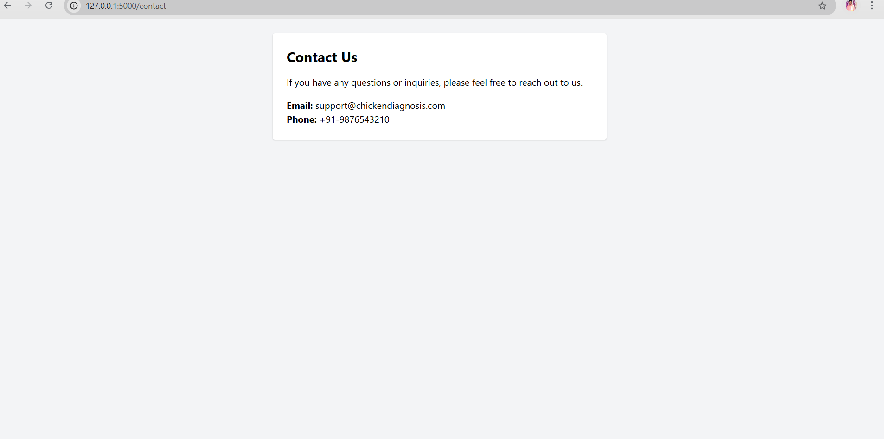

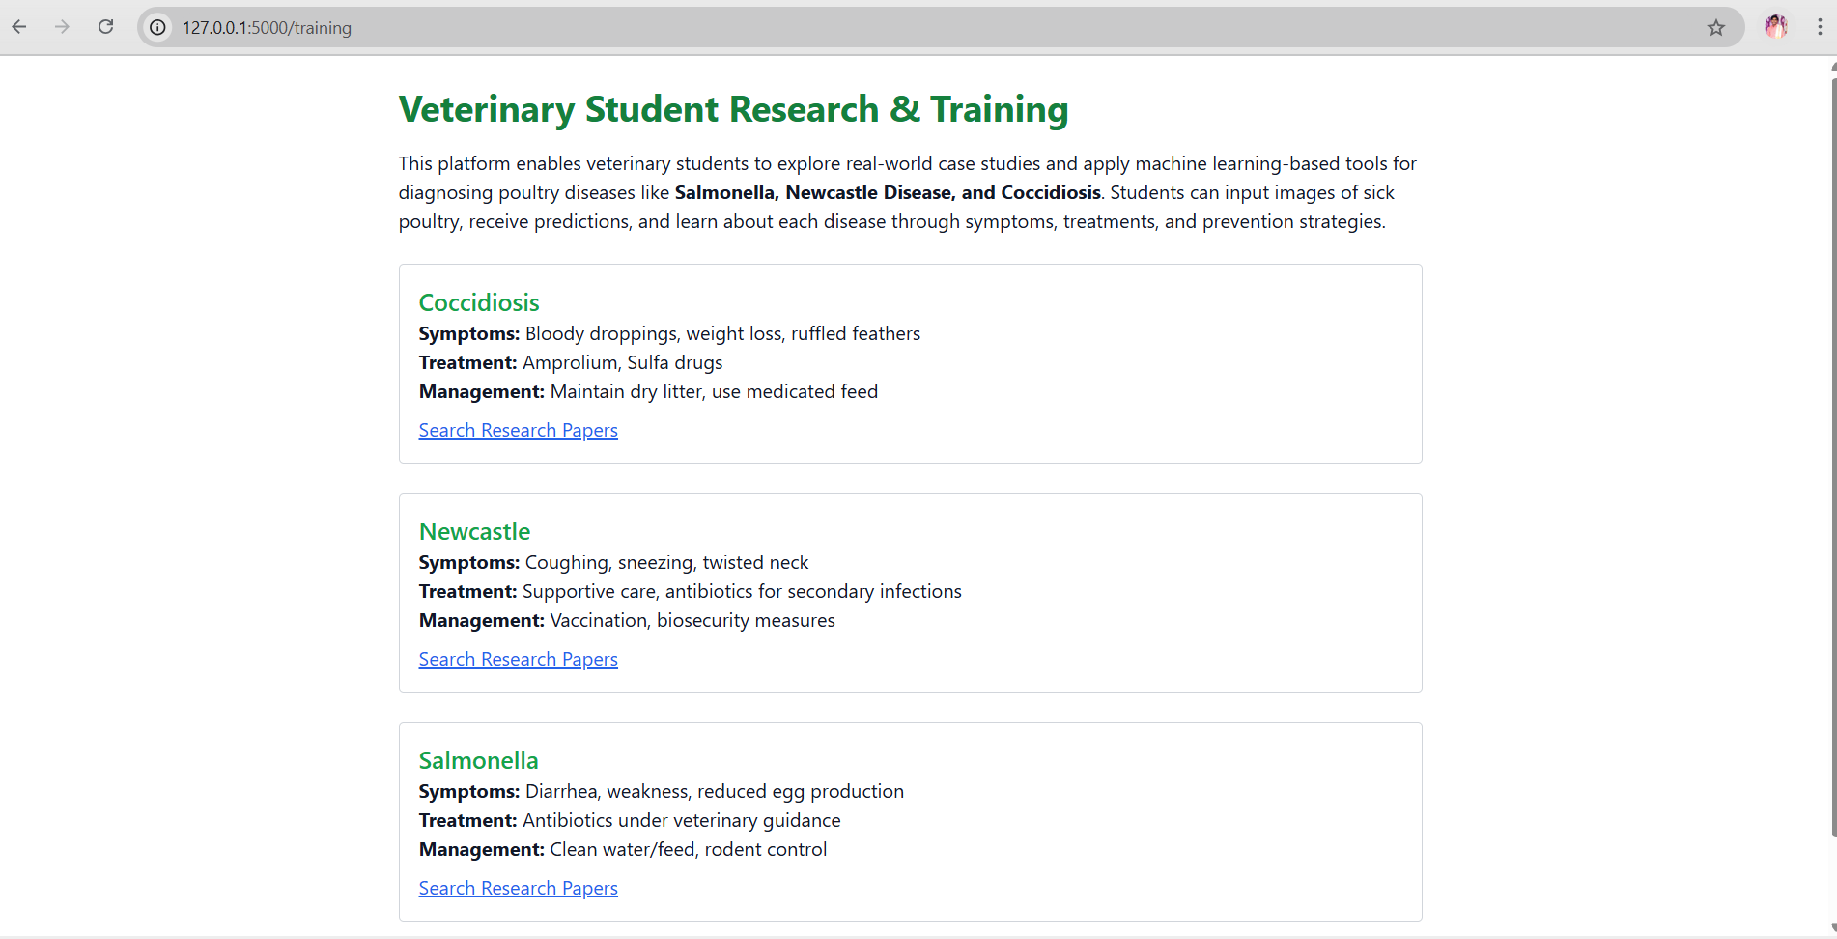

Veterinary students research & Training

# **8. ADVANTAGES & DISADVANTAGES**

**Advantages:**

* Easy to use
* Reduces dependency on vets
* Provides instant results

**Disadvantages:**

* Accuracy depends on image quality
* Limited to trained disease types

# **9. CONCLUSION**

The poultry disease classification tool successfully assists farmers in early disease detection, enabling timely treatment and reducing losses.

# **10. FUTURE SCOPE**

* Mobile app development
* Adding more diseases to the dataset
* Integrating real-time veterinary consultations

# **11. APPENDIX**

* **Source Code:** https://github.com/32edaramanikanta/poultry_disease
* **Dataset Link:** https://app.roboflow.com/manikanta-22kp1a4432/chicken-desease-speny/2t
* **Project Demo:** https://youtu.be/xDOPzgHvuA4

**Report By: Edara Bala Naga Venkata Siva manikanta**

**Team ID :** LTVIP2025TMID43589

**Team Size :** 4

**Team Leader :** Prattipati Shyam Prasad

**Team member :** Gopi Chaluvadi

**Team member :** Edara Bala Naga Venkata Siva Manikanta

**Team member :** Korrapati Praneeth Chowdary